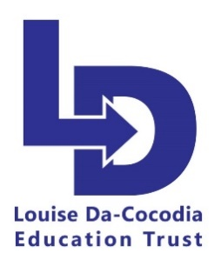

Louise Da-Cocodia Education Trust On-line Safety Young Person’s
Agreement.

Parents and carers: please read and discuss this agreement with your child and then sign it, ask your child to sign it, and return it to Sandra Garwood, On-line Support Co-ordinator

Young person’s agreement
1)I will be responsible for my behaviour when using the internet, including social media platforms, games and apps. This includes the resources I access and the language I use
2)I will not deliberately browse, download or upload material that could be
considered offensive or illegal. If I accidentally come across any such material I will
report it immediately to the On-line Support Co-ordinator
- 3)I will not send anyone material that could be considered threatening, bullying, offensive or illegal.
- 4)I will not give out any personal information online, such as my name, phone number or address.
- 5)I will not reveal my passwords to anyone
- 6)I will not arrange a face-to-face meeting with someone I meet online unless I have discussed this with my parents and/or On-line Support Co-ordinator and I am accompanied by a trusted adult.
- 7)If I am concerned or upset about anything I see on the internet or any messages that I receive, I know I can talk to the On-line Support Co-ordinator

I understand that my internet use at Louise Da-Cocodia Education Trust will be monitored and logged and can be made available to the On-Line Support Co-ordinator understand that these rules are designed to keep me safe and that if I choose not to follow them Louise Da-Cocodia Education Trust may contact my parents/carers.

Signatures:
We have discussed this online safety agreement and [child’s name] agrees to follow the rules set out above.

Parent/carer signature………………….………………….……………………………………………….. Date

Young person’s signature……………………........................................................................ Date ……………………………………………..

